**5.1. MapReduce program to filter out the invalid records. The output of this program will act as input for subsequent tasks. Map only job will fit for this context.**

**Driver class:**

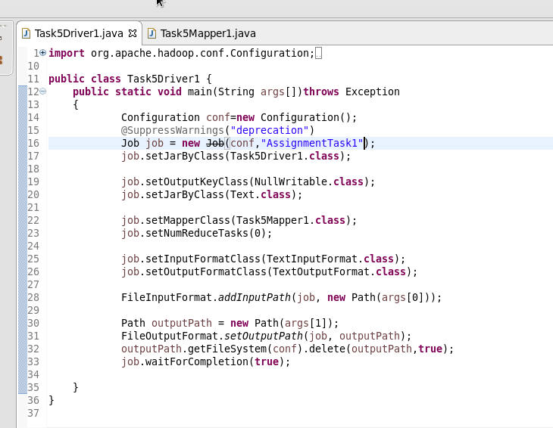

**MAPPER CLASS:**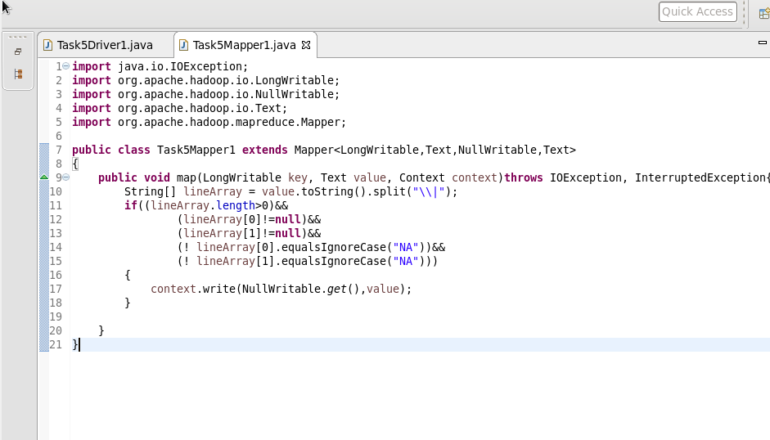

**SAMPLE INPUT:**

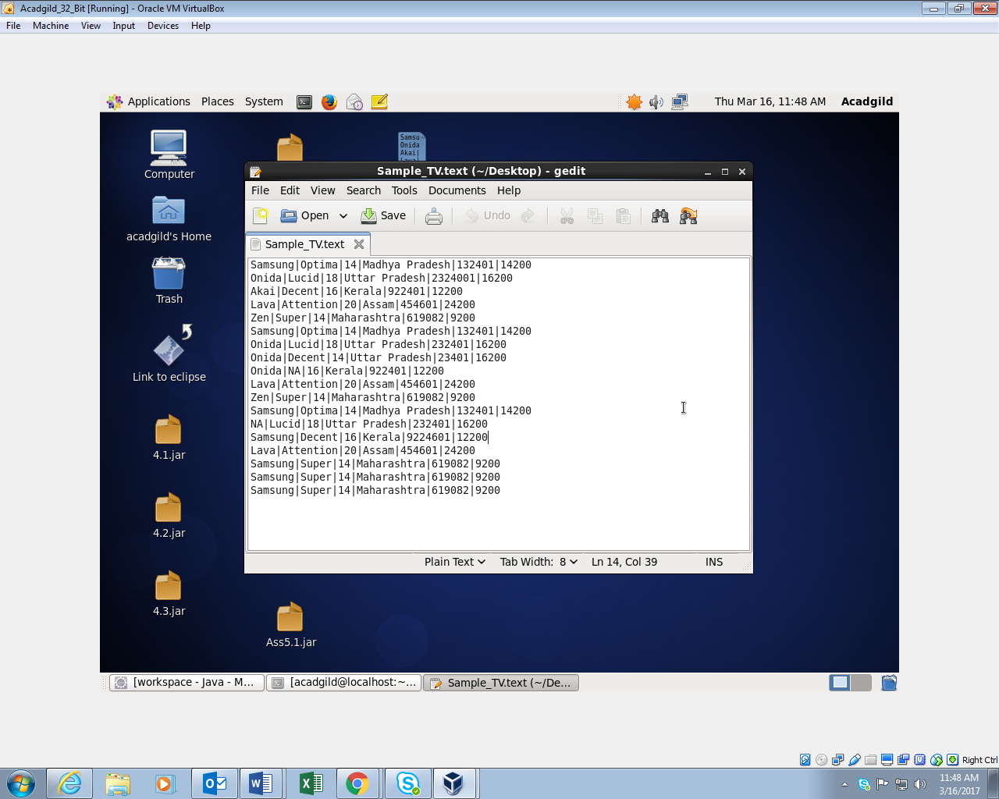

**OUTPUT:**

